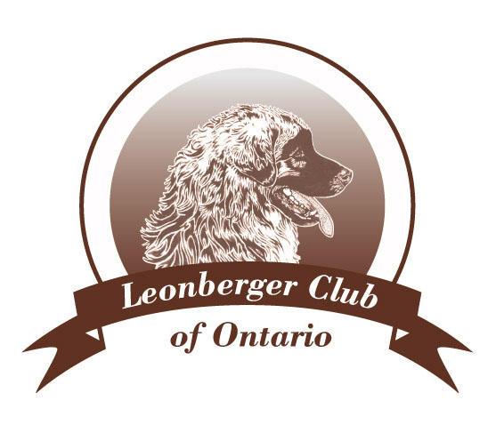

**Versatility Awards Program**

**Purpose:** To promote and recognize Leonbergers as they continue to work together with their owners/handlers in a variety of pursuits, proving their competence as versatile working dogs.

**Title Requirements**

**Versatility Companion (VC)** – LCO Versatility Entry title plus 5 points earned from a minimum of 3 categories.

**Versatility Companion Excellent (VCX)** – LCO Versatility Entry title plus 10 points from a minimum of 5 categories.

**Versatility Champion (VCH)** – LCO Versatility Entry title plus 15 points from 6 categories. At least 2 points each from 2 different categories must be earned at an intermediate or advanced level.

**Eligibility** - The owner and/or co-owner of the Leonberger shall be a member in good standing of the LCO at the time of application for certification.

**Activities considered for Versatility awards**

|  |  |  |  |  |  |
| --- | --- | --- | --- | --- | --- |
| **Category** | **Activity** | **1 Point** | **2 Points** | **3 Points** | **4 Points** |
| **Obedience** | Traditional Obedience | CD | CDX | UTD | OTCH |
|  | RallyO^ | RN | RA | RE | RAE |
| **Draft Work** | Drafting | DD | DDX |  |  |
| **Scent Work** | Tracking | TD | TDX | UTD |  |
|  | Scent Detection^ | Beginner | Advanced | Excellent |  |
| **Canine Sports** | Agility | AGN |  | AGI | AGX |
|  | Chase Ability | CA | CAX | CAX2 |  |
|  | Flyball^ | FbD | FbX | FbDCh |  |
|  | Dock Diving^ | Novice | Intermediate/Junior | Senior |  |
|  | Barn Hunt^ | RATN | RATO | RATS |  |
| **Stock Work** | Herding | HS | HTI | HTA | HC,HX |
| **Conformation** | Conformation | CH or CH(Alt) |  | GCH | GCHX |
| **Assistance Work** | Therapy Dog |  |  | Accredited course |  |
|  |  |  |  | certification |  |
|  | Service Dog |  |  | Accredited course |  |
|  |  |  |  | Certification |  |
|  | Search and Rescue |  |  |  | SAR certified |
|  | Heroic Feats |  |  | Documented |  |
| **Miscellaneous\*** | Modelling, Acting | 3 separate |  |  |  |
|  |  | occasions |  |  |  |
|  | Dance | 3 separate |  |  |  |
|  |  | workshops |  |  |  |
|  | Demos, Parades, | 3 separate |  |  |  |
|  | Seminars | occasions |  |  |  |

*These activities are to be verified in writing by 3 separate activity officials.

Equivalent titles for the Obedience, Draft Work, Scent Work, Canine Sports and Conformation from the UKC, AKC and foreign kennel clubs are accepted as are those from other recognized organizations (as noted by the ^ symbol).

To apply for any of the awards, please submit photocopies of titles, degrees, certifications and/or verifications to the Club Secretary along with a $5.00 processing fee.

If you and your dog have earned titles or certification for an activities not listed above, please let us know at [info@LeonbergerClubOfOntario.com](mailto:info@LeonbergerClubOfOntario.com) and we will be pleased to review the activity.